##### MALPRACTICE ANALYZER

##### (USING FACIAL RECOGNITION)

**A PROJECT REPORT**

###### 

###### ***Submitted by***

###### **Ananya Singh (19BCE10177)**

###### **Shreyash Mall (19BCE10054)**

*In partial fulfillment for the award of the degree*

*of*

##### 

##### BACHELOR OF TECHNOLOGY

*in*

**COMPUTER SCIENCE AND ENGINEERING**



**SCHOOL OF COMPUTING SCIENCE AND ENGINEERING**

**VIT BHOPAL UNIVERSITY**

**KOTHRIKALAN, SEHORE**

**MADHYA PRADESH – 466114**

APR 2021

**VIT BHOPAL UNIVERSITY, KOTHRIKALAN, SEHORE**

**MADHYA PRADESH – 466114**

**BONAFIDE CERTIFICATE**

Certified that this project report titled “**MALPRACTICE ANALYZER (USING FACIAL EXPRESSION)**”is the bonafide work of “**ANANYA SINGH (19BCE10177) and SHREYASH MALL (19BCE10054)**” who carried out the project work under my supervision. Certified further that to the best of my knowledge the work reported here does not form part of any other project / research work on the basis of which a degree or award was conferred on an earlier occasion on this or any other candidate.

**PROGRAM CHAIR PROJECT GUIDE**

Dr. M Ashwin Prof. Muneeswaran

School of Computer Science and Engineering School of Computer Science and Engineering

VIT BHOPAL UNIVERSITY VIT BHOPAL UNIVERSITY

The Project Exhibition II Examination is to be held on 05/05/2021.

**ACKNOWLEDGEMENT**

First and foremost I would like to thank the Lord Almighty for his presence and immense blessings throughout the project work.

I wish to express my heartfelt gratitude to Dr. M Ashwin, Head of the Department, School of Computer Science and Engineering for much of his valuable support encouragement in carrying out this work.

I would like to thank my internal guide Prof. Muneeswaran for continuously guiding and actively participating in my project, giving valuable suggestions to complete the project work.

I would like to thank all the technical and teaching staff of the School of Computer Science and Engineering, who extended all support directly or indirectly.

Last but not the least, I am deeply indebted to my parents who have been the greatest support while I worked day and night for the project to make it a success.

**ABSTRACT**

This report introduces the process of creating Machine Learning and Artificial Intelligence software ”Malpractice Analyzer Using Facial Expression” which ensures the smooth conduct of any examination. The software has two major components: AI Analyser and Interpreter. All of these components are designed and implemented by our group. The details will be introduced further in the report. This project is implemented using IDE “Python v3.8” to produce the software. It is an excellent open source software development kit for application development. The major part of this report is about our Project Development its Applications, limitations and Implementation process.

**TABLE OF CONTENTS**

|  |  |  |
| --- | --- | --- |
| **CHAPTER NO.** | **TITLE** | **PAGE NO.** |
| **1** | **INTRODUCTION**   * 1. Introduction   2. Objective of Project   3. Literature Overview | 6 |
| **2** | **LITERATURE SURVEY** | 8 |
| **3** | **SYSTEM ANALYSIS**  3.1 Proposed Work    3.2 Advantages of proposed Work | 9 |
| **4** | **SYSTEM DESIGN AND IMPLEMENTATION**  4.1 Software requirements  4.2 Hardware requirements | 11 |
| **5** | **PERFORMANCE ANALYSIS**  5.1 System Architecture Diagram | 12 |
| **6** | **RESULT AND SCREENSHOTS** | 14 |
| **7** | **PROJECT WORK AND METHODOLOGY** | 20 |
| **8** | **LIST OF TABLES IN DATABASES** | 21 |
| **9** | **RECOMENDATION FOR FUTURE WORK** | 23 |
| **10.** | **CONCLUSION**  6.1 Conclusion | 24 |
| **11.** | **REFERENCES** | 25 |

**Introduction**

Emotions instinctually influence our behaviours and every day decisions. As such, emotions are a great way to understand users’ interactions with products and it helps to inform our designs. But how can we measure emotion?

As the greatest expression of emotion can be seen on our faces, Facial Expression Analysis is a great method of measuring emotion and engagement.

The face has 43 facial muscles. One single facial nerve can be attributed to triggering almost all of our facial muscles. The other facial nerve, Oculomotor nerve, controls the upper eyelid and pupils.

With these 43 facial muscles, our faces show varying emotions including 7 core emotions which are Anger, Contempt, Disgust, Fear, Joy, Sadness and Surprise.

* 46 Main Action Units in which each facial motion is broken down from the eyebrows, eyes, nose, mouth, and chin to note things like raised eyebrows, squinting and smiling.
* Eight Head Movement Action Units capture head tilts or movement of the head forward or back.
* Four Eye Movement Action Units note the eyes moving to the left or right, or up or down.

We have developed software which can detect the facial expression of a person and eye movements to track down whether a person is trying any sort of malpractice. After that it generates a particular report on how much likely the candidate is involved in malpractice.

**Objective of Project**

The project involves in development of software to analyse the Facial Expression and Eye Movement of any candidate through Webcam and generate an accurate report on how likely the person may involve in malpractice.

**Literature Review**

Python is an interpreted high-level general-purpose programming language. Python's design philosophy emphasizes code readability with its notable use of significant indentation. Its language constructs as well as its object-oriented approach aim to help programmers write clear, logical code for small and large-scale projects.

Python is dynamically-typed and garbage-collected. It supports multiple programming paradigms, including structured (particularly, procedural), object-oriented and functional programming. Python is often described as a "batteries included" language due to its comprehensive standard library.

**SYSTEM ANALYSIS:**

**Proposed Work**

This Project is based on android application development which includes a One Tap Button, to activate emergency services like emergency call and a SMS which shares a text snippet with current location. The other activities included are a Contact storing page, Nearby Distress Location, Real-time Location Tracker and About section. As it is an elegant and basic application with less size and RAM requirement it can be used in low-end smartphones. It is reliable application but further developments in the project can be made for generating a market competitive application with fewer flaws.

**Advantages of the Proposed Work**

* Cross-platform
* Works with glasses
* Does not require high-end hardware, works well even with a 640*480 webcam
* Uses blob detection algorithm, but earlier versions used circle detection too.
* Highly extensible/flexible

**SYSTEM DESIGN AND IMPLEMENTATION:**

**Software Requirements:**

Python 3(will work with 2.7 if you install custom PyQT5 for it)

PyQT 5(to install it for 2.7 use pip install python-qt5 WARNING: Windows-only)

OpenCV 3.4 +

NumPy 1.15.2 +

**Hardware requirements:**

1. **Laptop/P.C.:**

A well-functioning Laptop with i-7 processor and RAM above 4GB for smooth workflow.

1. **Human Model**

**PERFORMANCE ANALYSIS:**

**System Architecture Diagram**

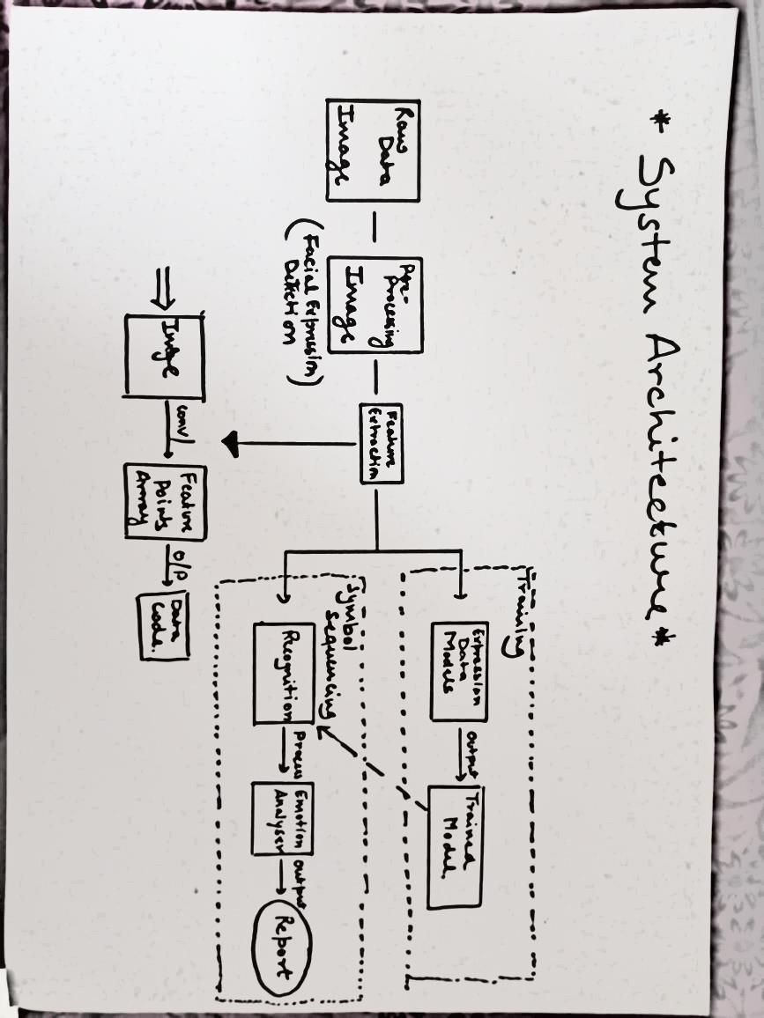

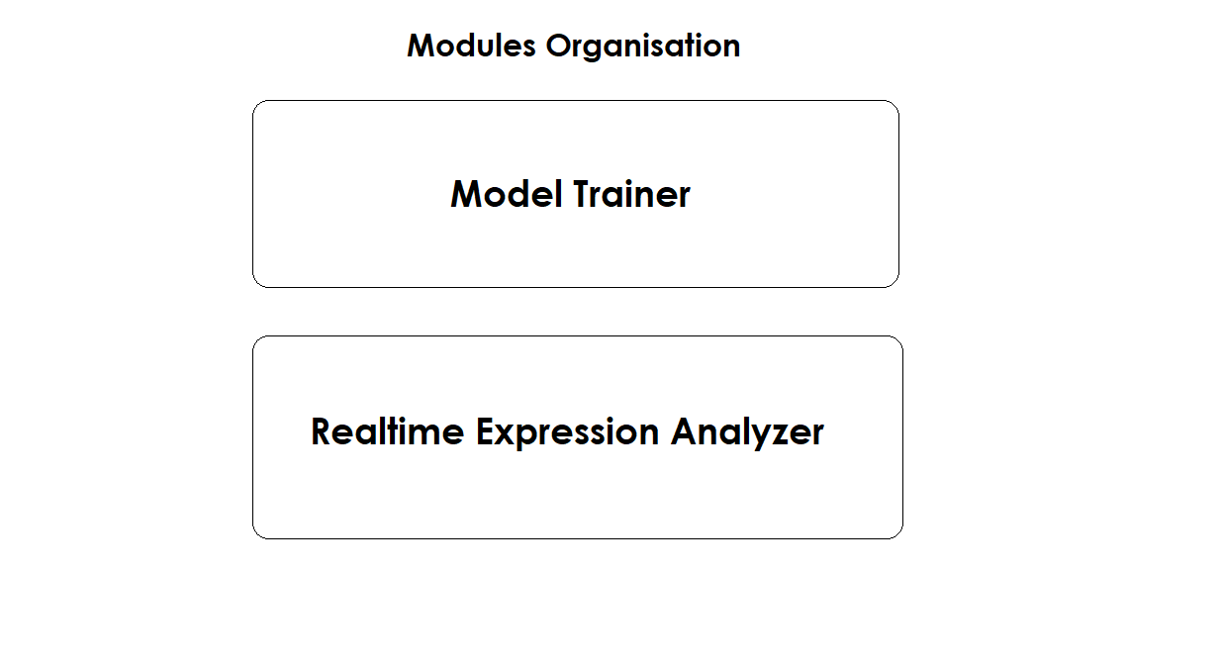

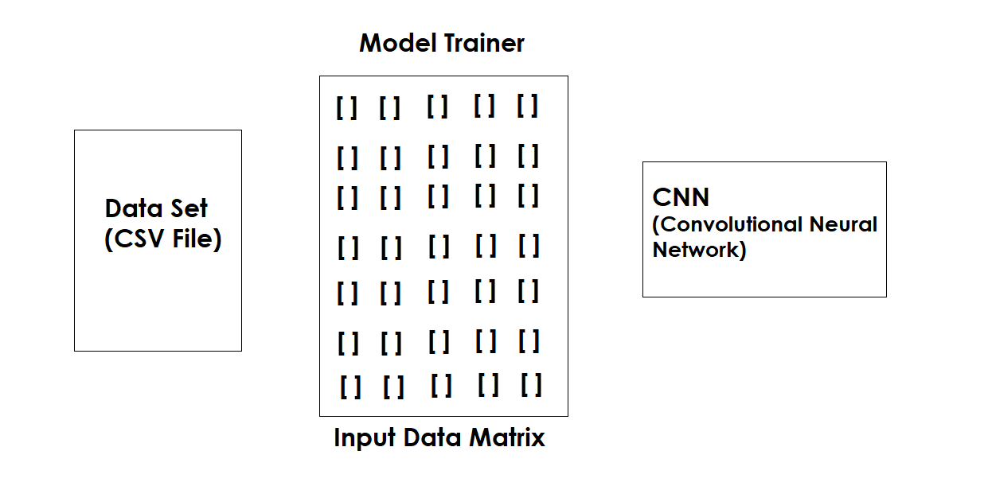

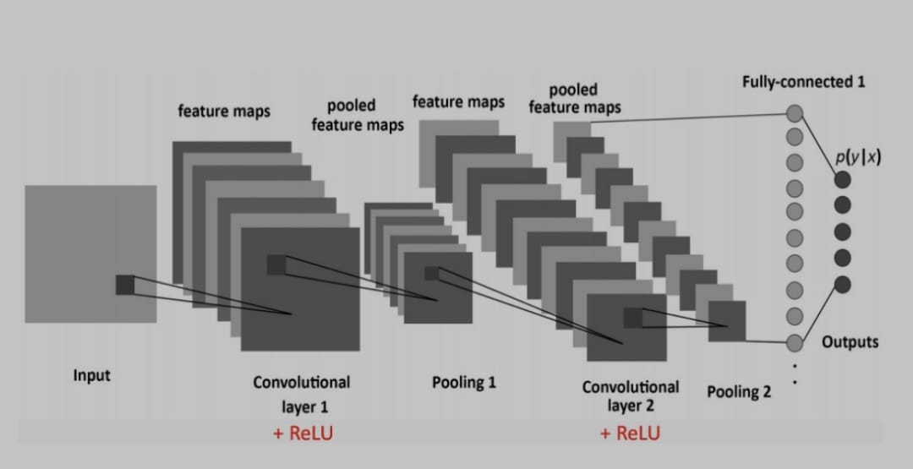

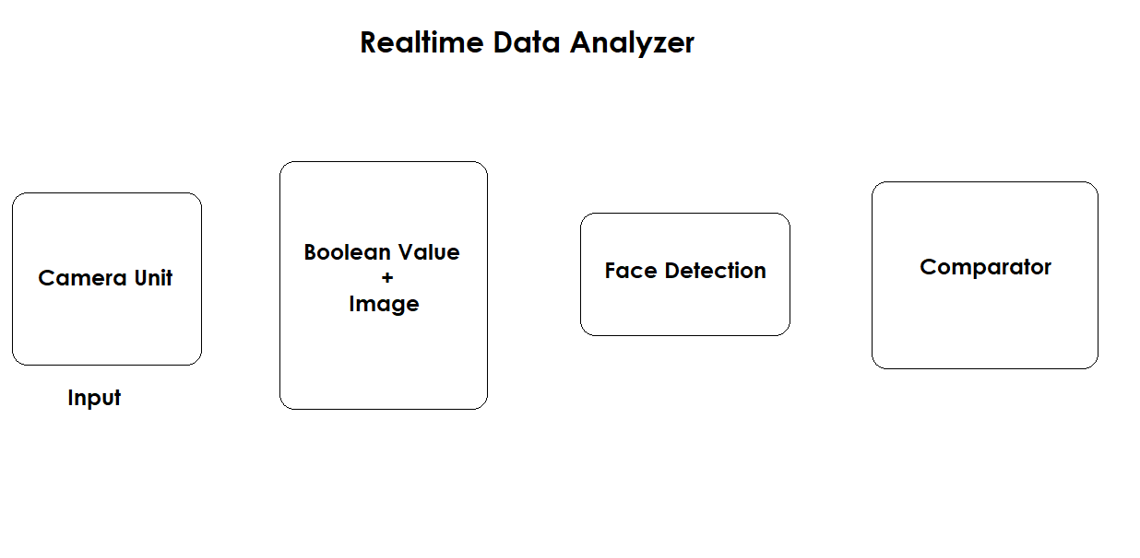

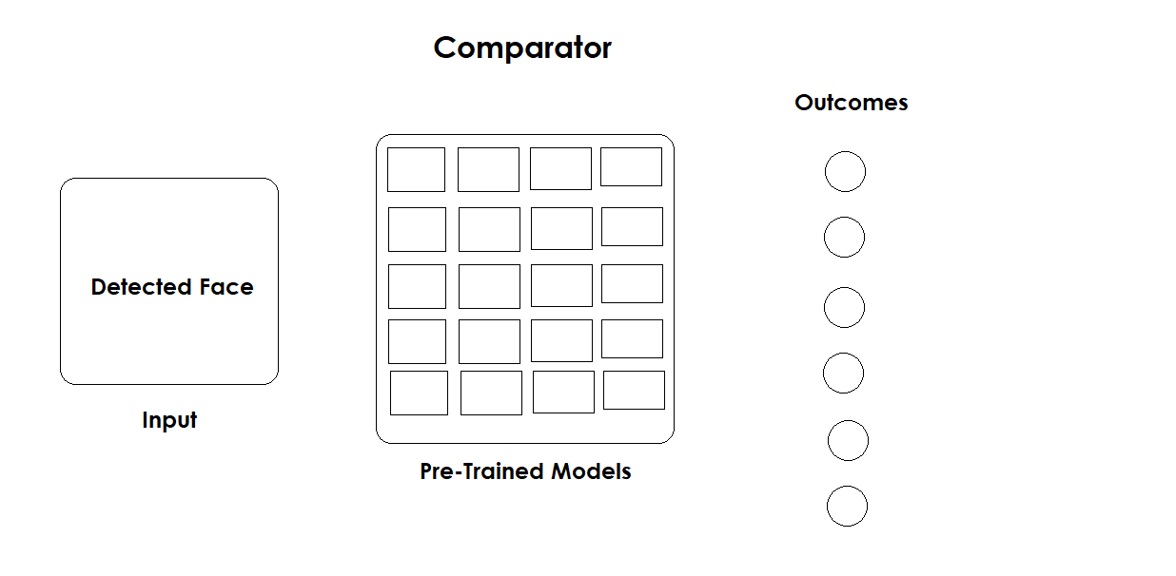

1. Design Layout

**Testing**

Table 1 – Basic Expression Testing

|  |  |  |  |  |
| --- | --- | --- | --- | --- |
| S.No. | Test Case | Pre- Condition | Post- Condition | Result |
| 1 | Detection of Facial Area | Raw Image Feed | Rectangular Blob around Facial Area | Pass |
| 2 | Drawing of blob around Facial Area | Raw Image Feed | Rectangular Blob around Facial Area | Pass |
| 3 | Emotion Prediction Model | Haar-Cascade Model  (CSV File) | Developed Emotion Prediction Model | Pass |
| 4 | Accuracy of Model | Minimum Epoch = 50 | Accuracy =92.83% | Pass |
| 5 | Prediction of Emotion | None | None | Pass |
| 6 | Deduction of Emotion  (Happy) | Facial Area Recognized | Display of result (Happy) | Pass |
| 7 | Deduction of Emotion  (Neutral) | Facial Area Recognized | Display of result (Neutral) | Pass |
| 8 | Deduction of Emotion  (Fear and Other) | Facial Area Recognized | Display of result (Fear and Other) | Pass |

**RESULT AND SCREENSHOTS**

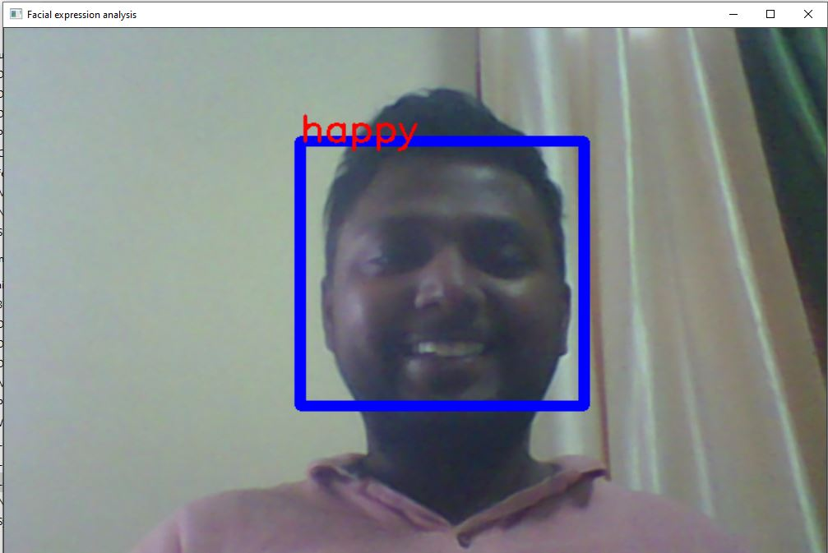

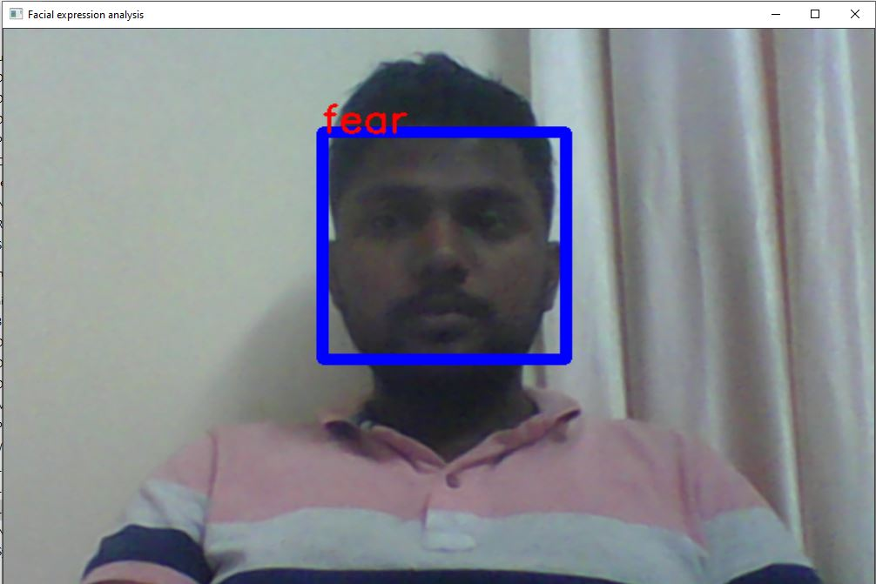

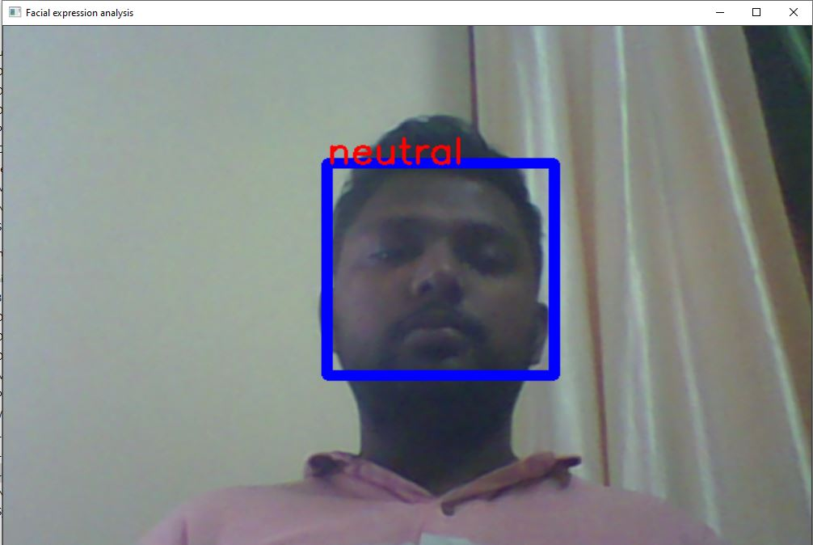

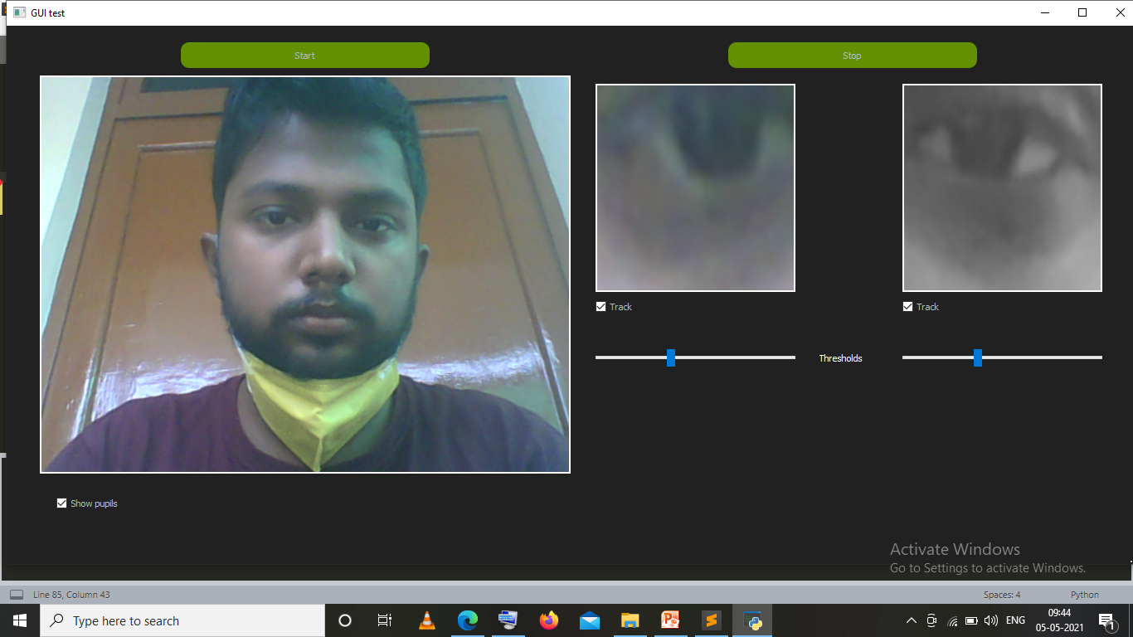

**RECOMENDATION FOR FUTURE WORK**

* This project can be further developed by using Machine Learning and Artificial Intelligence.
* The Prediction Model can further be developed for better design, graphics and accuracy can be used for making the software more interactive.
* Better accuracy in Prediction Model can be achieved using more Data Set.
* Software can be upgraded in many aspects and it’s an iterative process.

**Conclusion**

The project we made is easy to use and handle. With knowledge of Machine Learning good interactive software can be developed.

With more improvements the software can compete with others in market. The application is **memory friendly**, **multi-platform operable**, **accurate Prediction Model**, **versatile**, **accurate interpretation of expression**. It has a simple yet elegant design making it easy for user to operate.

**Malpractice Analyser** was our first attempt as an AI application. It gave us a very good exposure towards the Machine Learning and Artificial Intelligence as well as developing industrial skills. Through this software we understand the basics of Machine Learning, generating, testing and optimising software.

Also it helped us in building teamwork skills and generated further interest in Software Development for the betterment in application and mankind.

**References**

* <https://developer.mozilla.org>
* <https://developers.google.com>
* <https://machine.learning.org>